Circular Rims
# Source: AI Source: Provided by: [Data Path: Persons Table -> ID Column: 1, Name_En Column: Motasem Essam] -> From: [ChatGPT] on [7/25/2026]
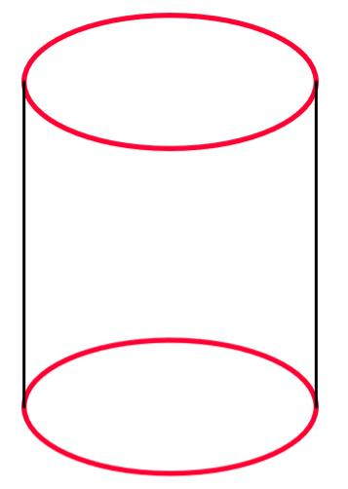
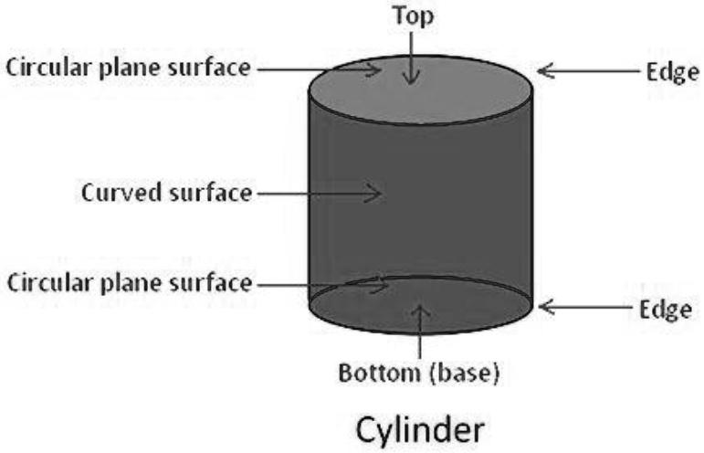
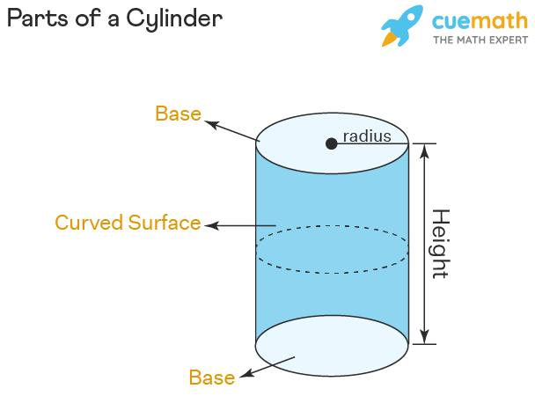

Definition
# Source: AI Source: Provided by: [Data Path: Persons Table -> ID Column: 1, Name_En Column: Motasem Essam] -> From: [ChatGPT] on [7/25/2026]
The circular rims of a cylinder are the circular boundary curves at the edges of its two circular bases. A standard closed circular cylinder has two rims: one surrounding the top base and one surrounding the bottom base.
Each rim is the circumference of its corresponding circular base. The rims define the circular edges where the bases meet the curved lateral surface.

Simple Definition
# Source: AI Source: Provided by: [Data Path: Persons Table -> ID Column: 1, Name_En Column: Motasem Essam] -> From: [ChatGPT] on [7/25/2026]
Circular rims are the round edges around the top and bottom of a cylinder.
For example, the circular edge around the opening of a cylindrical can is a rim.

Geometric Representation and Components
# Source: AI Source: Provided by: [Data Path: Persons Table -> ID Column: 1, Name_En Column: Motasem Essam] -> From: [ChatGPT] on [7/25/2026]
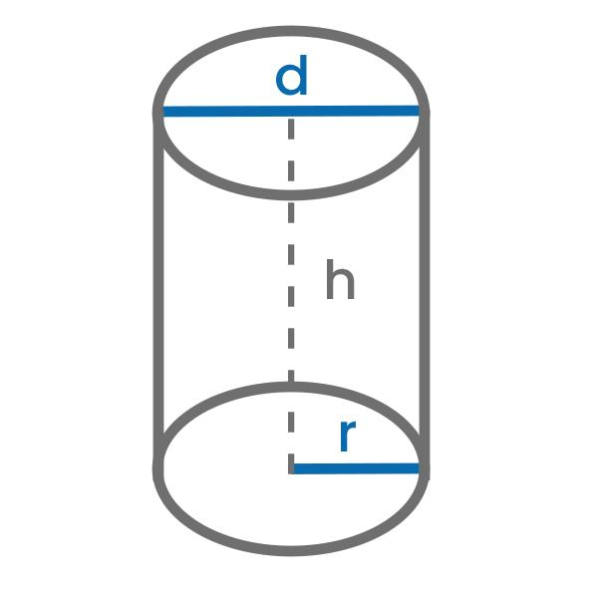
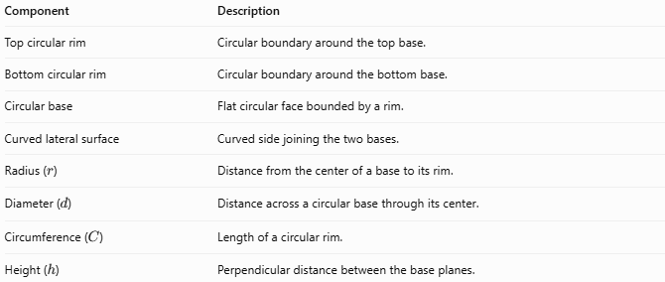
Component | Description
Top circular rim | Circular boundary around the top base.
Bottom circular rim | Circular boundary around the bottom base.
Circular base | Flat circular face bounded by a rim.
Curved lateral surface | Curved side joining the two bases.
Radius ($r$) | Distance from the center of a base to its rim.
Diameter ($d$) | Distance across a circular base through its center.
Circumference ($C$) | Length of a circular rim.
Height ($h$) | Perpendicular distance between the base planes.
For an ordinary circular cylinder, the two rims have equal radii and equal circumferences because the bases are congruent.

Types and Classification

Top Circular Rim
# Source: AI Source: Provided by: [Data Path: Persons Table -> ID Column: 1, Name_En Column: Motasem Essam] -> From: [ChatGPT] on [7/25/2026]
The top circular rim is the boundary curve surrounding the upper circular base. It marks the edge where the top base meets the curved lateral surface.

Bottom Circular Rim
# Source: AI Source: Provided by: [Data Path: Persons Table -> ID Column: 1, Name_En Column: Motasem Essam] -> From: [ChatGPT] on [7/25/2026]
The bottom circular rim is the boundary curve surrounding the lower circular base. It marks the edge where the bottom base meets the curved lateral surface.

Outer Rim
# Source: AI Source: Provided by: [Data Path: Persons Table -> ID Column: 1, Name_En Column: Motasem Essam] -> From: [ChatGPT] on [7/25/2026]
In a hollow cylinder or pipe, the outer rim is the circular edge at the outside boundary of an end.

Inner Rim
# Source: AI Source: Provided by: [Data Path: Persons Table -> ID Column: 1, Name_En Column: Motasem Essam] -> From: [ChatGPT] on [7/25/2026]
In a hollow cylinder or pipe, the inner rim is the circular edge surrounding the opening at an end.
A hollow cylindrical pipe generally has four circular boundary edges: an inner and an outer rim at each end.

Mathematical Properties and Formulas

Circumference of a Circular Rim
# Source: AI Source: Provided by: [Data Path: Persons Table -> ID Column: 1, Name_En Column: Motasem Essam] -> From: [ChatGPT] on [7/25/2026]
The length of one circular rim equals the circumference of its base:
$$\boxed{C=2πr}$$
Using the diameter $d=2r$:
$$\boxed{C=πd}$$

Total Length of Both Rims
# Source: AI Source: Provided by: [Data Path: Persons Table -> ID Column: 1, Name_En Column: Motasem Essam] -> From: [ChatGPT] on [7/25/2026]
For a circular cylinder with congruent bases, the total length of the top and bottom rims is:
$$C_{\text{both}}=2C$$
Therefore:
$$\boxed{C_{\text{both}}=4πr}$$
Or, using the diameter:
$$\boxed{C_{\text{both}}=2πd}$$

Radius from the Rim Length
# Source: AI Source: Provided by: [Data Path: Persons Table -> ID Column: 1, Name_En Column: Motasem Essam] -> From: [ChatGPT] on [7/25/2026]
If the circumference of one rim is known:
$$\boxed{r=\frac{C}{2π}}$$

Diameter from the Rim Length
# Source: AI Source: Provided by: [Data Path: Persons Table -> ID Column: 1, Name_En Column: Motasem Essam] -> From: [ChatGPT] on [7/25/2026]
$$\boxed{d=\frac{C}{π}}$$

Hollow Cylinder Rims
# Source: AI Source: Provided by: [Data Path: Persons Table -> ID Column: 1, Name_En Column: Motasem Essam] -> From: [ChatGPT] on [7/25/2026]
For a hollow cylinder with outer radius $R$ and inner radius $r$:
$$C_{\text{outer}}=2πR$$
$$C_{\text{inner}}=2πr$$
The combined length of all four circular boundary edges is:
$$\boxed{C_{\text{all}}=4π\left(R+r\right)}$$
This last formula counts both inner and outer rims at both ends.

Worked Examples
# Source: AI Source: Provided by: [Data Path: Persons Table -> ID Column: 1, Name_En Column: Motasem Essam] -> From: [ChatGPT] on [7/25/2026]
Example 1 — Find the Length of One Circular Rim
A cylinder has a base radius of $7\text{ cm}$. Find the circumference of one rim.
Solution:
$$C=2πr$$
$$C=2π\left(7\right)$$
$$\boxed{C=14π\text{ cm}≈43.98\text{ cm}}$$
Example 2 — Find the Combined Length of Both Rims
A cylinder has a diameter of $10\text{ m}$. Find the combined length of its top and bottom rims.
Solution:
$$C_{\text{both}}=2πd$$
$$C_{\text{both}}=2π\left(10\right)$$
$$\boxed{C_{\text{both}}=20π\text{ m}≈62.83\text{ m}}$$
Example 3 — Find the Radius from the Rim Length
The circumference of a circular rim is $24π\text{ mm}$. Find the radius.
Solution:
$$r=\frac{C}{2π}$$
$$r=\frac{24π}{2π}$$
$$\boxed{r=12\text{ mm}}$$
Example 4 — Calculate the Rim Lengths of a Hollow Cylinder
A hollow cylindrical pipe has an outer radius of $6\text{ cm}$ and an inner radius of $4\text{ cm}$. Find the combined length of all four circular boundary edges.
Solution:
$$C_{\text{all}}=4π\left(R+r\right)$$
$$C_{\text{all}}=4π\left(6+4\right)$$
$$\boxed{C_{\text{all}}=40π\text{ cm}≈125.66\text{ cm}}$$

Circular Rims Compared with Related Elements
# Source: AI Source: Provided by: [Data Path: Persons Table -> ID Column: 1, Name_En Column: Motasem Essam] -> From: [ChatGPT] on [7/25/2026]
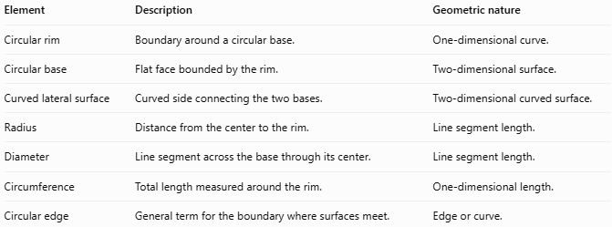
Element | Description | Geometric nature
Circular rim | Boundary around a circular base. | One-dimensional curve.
Circular base | Flat face bounded by the rim. | Two-dimensional surface.
Curved lateral surface | Curved side connecting the two bases. | Two-dimensional curved surface.
Radius | Distance from the center to the rim. | Line segment length.
Diameter | Line segment across the base through its center. | Line segment length.
Circumference | Total length measured around the rim. | One-dimensional length.
Circular edge | General term for the boundary where surfaces meet. | Edge or curve.
Important distinction: A rim is the circular boundary itself, while the circumference is the measured length of that boundary.

Applications
# Source: AI Source: Provided by: [Data Path: Persons Table -> ID Column: 1, Name_En Column: Motasem Essam] -> From: [ChatGPT] on [7/25/2026]
Circular rims are important in the design and measurement of:
- Cans and containers: identifying the circular edges around lids and bases.
- Pipes and tubes: measuring inner and outer end boundaries.
- Mechanical components: defining circular edges on cylindrical parts.
- Manufacturing: checking edge dimensions and fitting accuracy.
- Packaging: calculating the length of material needed to cover a circular edge.
- Geometry and technical drawing: identifying where flat bases meet curved surfaces.

Key Points
# Source: AI Source: Provided by: [Data Path: Persons Table -> ID Column: 1, Name_En Column: Motasem Essam] -> From: [ChatGPT] on [7/25/2026]
- A standard closed circular cylinder has two circular rims.
- Each rim is the circumference of one circular base.
- The two rims have equal circumferences in a cylinder with congruent circular bases.
- One rim's length is $C=2πr=πd$.
- The combined length of both rims is $4πr=2πd$.
- A hollow cylinder generally has inner and outer rims at each end.
- A rim is a boundary curve, not a flat face or a curved surface.

Conclusion
# Source: AI Source: Provided by: [Data Path: Persons Table -> ID Column: 1, Name_En Column: Motasem Essam] -> From: [ChatGPT] on [7/25/2026]
The circular rims of a cylinder are the circular boundaries surrounding its top and bottom bases. They define the edges where the bases meet the curved lateral surface.
The most important formula for one rim is:
$$\boxed{C=2πr}$$
For both rims of a cylinder with congruent circular bases:
$$\boxed{C_{\text{both}}=4πr}$$

